**Lab exercise 7: Dielectric Spectroscopy Test**

**7.2 Why dielectric spectroscopy?**

How the previous curve shifts in case of:

A. Different moisture content.

B. Different aging conditions.



Figure 7.1: Factors affecting the frequency-dependent dissipation factor[1].

A: For a high moisture content (4%) the dissipation factor will increase in low and high frequency range as you can see in figure 7.1. In this two ranges the moisture content a high impact to shift the curve. Low moisture content shifts the curve to lower dissipation factor in low and high frequency range.

B. If the aging process is advanced on the insulator, the curve will shift to the right. This means that the dissipation factor for the medium frequency range (1 Hz) will increase compared to an isolator that does not show aging yet. In low frequency range the dissipation factor will have the same value. For high frequency range (1000 Hz) the dissipation factor will increase because of the shift to the right of the curve.

**7.3 Test setup**

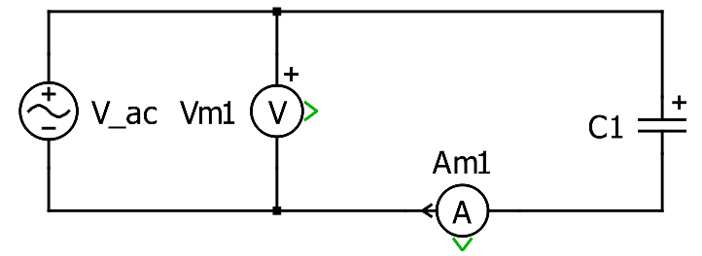

Figure 7.2: Schematic of the dielectric spectroscopy test setup.

For the dielectric spectroscopy test an insulator is used instead of a transformer. This is shown in the diagram as a capacitor, see Figure 7.2. For the power supply the DIRANA device is used, which also serves as an analyzer. The DIRANA can generate voltage at different frequencies. For the dielectric spectroscopy test the isolator is supplied with voltage in the frequency range from 1mHz to 5kHz. Since DIRANA is also an analyzer, the voltage and the current can be measured simultaneously. From 100 mHz, the supply is switched from 100 V AC to 100 V DC to accelerate the process. In addition, the calculation method changes from FDS to PDC. PDC measures the polarization current and the depolarization current and transfers the currents to the frequency domain to obtain the dissipation factor.

**7.4 Experimental results: moisture content and conductivity**

Define the moisture category. Is it necessary to apply any dry methods?

The Transformer belongs to the moisture category extremely wet (m. c.: over 4.8%). The figure 1 shows the measurement curve from the transformer (blue) comparing a simulate curve for a moisture content over 5.2% (red). The blue curve is located in large parts above the red curve. Based on these observations it can be concluded that the transformer has a moisture content of over 4.8 % and therefore belongs to the extremely wet category. Therefore it is necessary to use some dry methods to reduce the moisture content.

Discuss the results and give an assessment of the condition of the voltage transformer

In lower frequency you can see that the value of the dissipation factor from the transformer is higher than the red reference curve, as you can see in figure 7.3. The aging process in cellulose is well advanced. In the frequency domain 0.1 to 1 the red and the blue curve quit similar behavior.1 Hz and higher the dissipation factor from the transformer is higher than the dissipation factor from the simulation curve. This means that the oil conductivity from the transformer is higher than the simulation one.

The transformer is in not so good condition. If you compare the curve with a reference curve for a moisture content 5.2 %, the transformer dissipation factor is almost every frequency higher or equal to the reference value(red curve). The transformer should be subjected to a drying method so that it can continue to be used in the future.

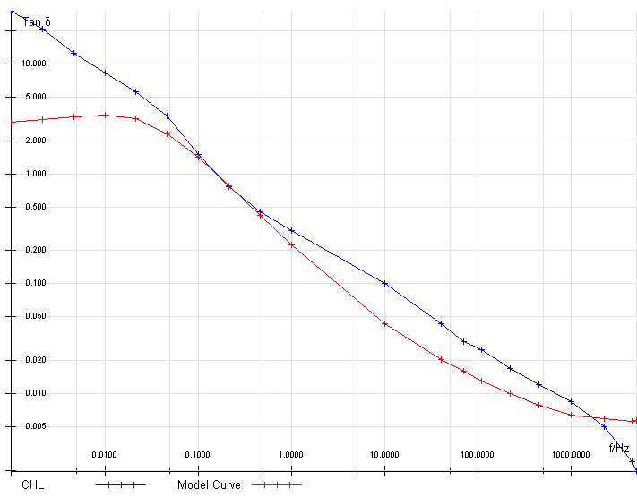

Figure 7.3: Result of the test.

Bibliography

[1] Lab exercise introduction 7